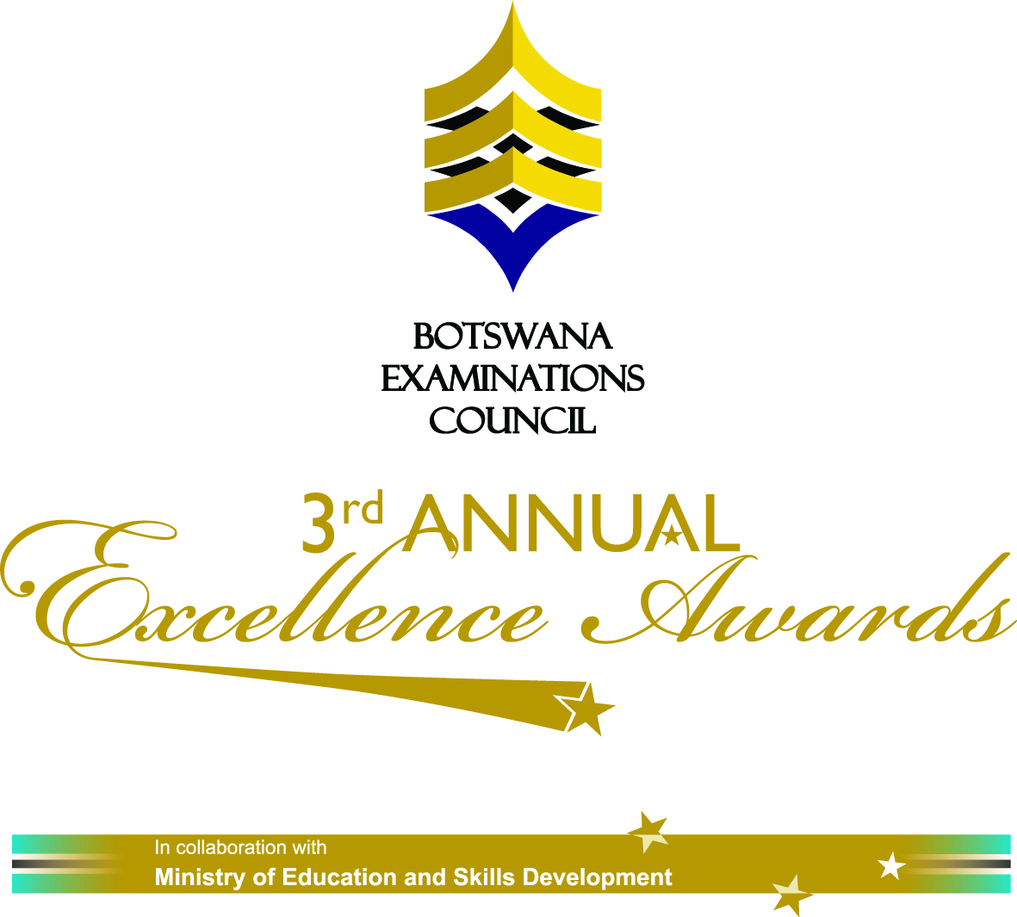

Private Bag 0070
Gaborone

BEC 5/9/3 I (33)

Attention: All Media Houses

PRESS RELEASE: 3rd ANNUAL EXCELLENCE AWARDS
Botswana Examinations Council 3rd Annual Excellence Awards in Collaboration with the Ministry of Education and Skills Development will be held on the 1st of June 2012 at Gaborone International Convention Centre.
His Excellency President Seretse Khama Ian Khama will officiates the event where 78 best performers during the 2011 national examinations from the Primary school leaving Examination to Botswana General Certificate of Secondary Education will receive awards during the glittering ceremony.
His Excellency the President will also award the Golden Star Presidential Award on the Day to the best student who out performed others during the 2011 national examinations at BGCSE level while the Minister of Education and Skills Development Honorable Pelonomi Venson-Moitoi will give a ministerial award to the second best overall performer still at BGCSE level.

The Excellence Awards are geared towards encouraging good performance during national examinations at primary and secondary sub sectors and contribute to the national human resources strategy and Vision 2016 pillar of an educated and informed nation by recognizing those students who excel during such examinations at PSLE, JCE and BGCSE levels and rewarding them accordingly.

It is hoped that through such awards, recipients would also become role models to be emulated by those who are still to go through the same national examinations.
Other awards on the day will include the Ministerial award given to a government school which performed the best nationally during the 2011 examinations together with its Parents Teachers Association at PSLE, JCE and BGCSE levels.

For more information on the Awards, please contact the Botswana Examinations Council Public Relations Office at 3650700.

Thank you.

___________________
Charles Keikotlhae
Public Relations Officer

